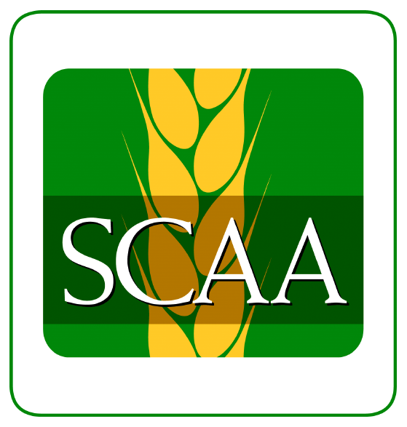
Introduction to Basic Archives Workshop
July 23, 2018 – 10:00 am to 4:30 pm
Craik Oral History Archives
310 3rd Street
Craik, SK.

The SCAA is pleased to offer a one-day workshop that will introduce participants to the basic archival functions of acquisition, accessioning, appraisal, arrangement, description and reference. Questions about what and why we archive will be discussed as well as issues related to the conservation/preservation of archival materials.

Instructor: Cameron Hart, SCAA Archives Advisor

Maximum Attendees: 10

Workshop Fees:
*Registration for this workshop is FREE but we kindly request that you fill in this form so that we can prepare the venue and material for the appropriate number of attendees.

Registration Deadline: July 20, 2018

Institution/Organization: ___________________________________________________

Address: _____________________________________ City: ______________________

Phone: _____________________ Email: ______________________________________

Name of Attendee(s): ____________________________________________________

____________________________________________________

____________________________________________________
(For more than 3 attendees please complete an additional registration form)

Submit registration forms to:
Gloria Bearss, SCAA Executive Director
#202-1275 Broad Street
Regina, SK S4R1Y2
Phone 306-780-9414; Email: scaa@sasktel.net ; Fax 306-585-1765.

For further information on workshop content contact:
Cameron Hart, Archives Advisor
Email: scaa.advisor@sasktel.net; Phone: 306-242-0796

