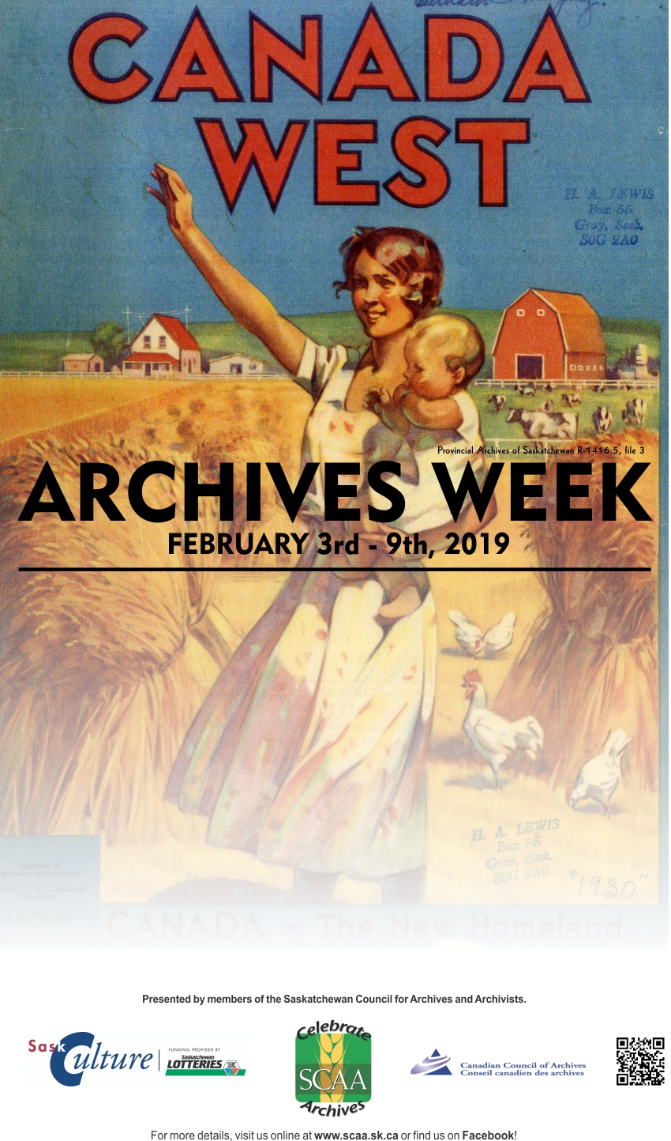

**HEADING AND TEXT HERE**

CONTENT HERE